Event-based surveillance evaluation guidance and toolkit

Summary: This document describes key steps and methodologies and offers operational tools for undertaking a comprehensive evaluation of an event-based surveillance (EBS) system. This guide and toolkit will aid countries, regions, and partners in designing, conducting, and analyzing outcomes from an EBS evaluation. Intended users include sub-national, national, regional, and global-level early warning surveillance program implementers and supporting partners. Outcomes from an evaluation will help identify best practices and areas of improvement, as well as offer recommendations to enhance the effectiveness and efficiency of these critical systems.
Contents
Background 2
Phased Approach: 3
Phase 1. Planning 4
Phase 2: Protocol and Tool Development 6
Evaluation Methods 6
Quantitative Methods 10
Qualitative Methods 16
Additional Analysis 18
Ethical Review and Considerations 23
Phase 3: Implementation 23
Phase 4: Outcomes and Next Steps 25
Acknowledgement 30
References 31
Appendix 35
Glossary 35
List of Supplemental Evaluation Tools 40
Example Protocol Template 40
Example EBS Site Evaluation Checklist 41
Informed Consent and Confidentiality 43

Background
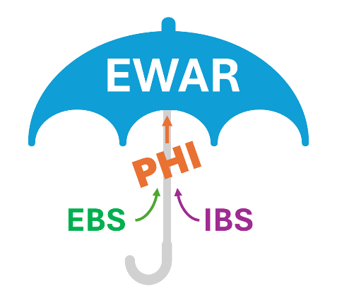
Event-based surveillance (EBS) systems have been implemented globally to support public health intelligence (PHI) and strengthen early warning, alert and response (EWAR) capacity across human, animal, and environmental health in diverse settings. Like all public health programs^{1,2}, EBS systems should be evaluated periodically to ensure that they are continuing to meet their objectives related to the early detection of health-related threats and to identify areas for process improvement regarding the quality, efficiency, and usefulness of these systems. To date, there has been limited guidance^{3,4} on how to approach the evaluation of EBS systems. This absence has hindered the ability for programs to measure impact and improve program performance in the field.
Figure 1. Both event-based and indicator-based surveillance contribute to public health intelligence (PHI), which overall informs early warning, alert, and response efforts.
EBS is defined by the World Health Organization (WHO)⁵ as the organized collection, monitoring, assessment and interpretation of mainly unstructured ad hoc information regarding health events that may represent an acute risk to human health. EBS has emerged as a crucial complement to indicator-based surveillance (IBS), particularly in resource-limited settings^{6,7} where diagnostic capacities and established surveillance infrastructures are often lacking. EBS encompasses a wide array of information sources, from the community, news articles, and social network messages to direct reports from healthcare and community health workers. Events of interest can include unusual patterns of disease, clusters of illness or unexpected deaths in plants, animals, and humans, extreme weather events, and environmental hazards – occurring within a country or across its borders. The flexibility and broad scope of EBS systems enable the early detection of health threats that traditional IBS systems might be delayed in reporting or miss completely due to its more routine and specific nature, thereby enhancing global health security and upholding the International Health Regulations (IHR 2005).
Under the IHR (2005) Monitoring and Evaluation Framework (MEF)⁸, a roadmap for assessing a country’s health security capacity is defined and composed of four processes: State Parties Annual Reporting (SPAR)⁹, Joint External Evaluations (JEE)¹⁰, After Action Reviews (AAR)¹¹, and Simulation Exercises (SIMEX)¹². Of these four assessments, only the JEE contains evaluation markers for EBS programs though not in detail. Noting this lack of detailed guidance, Africa CDC updated their EBS Framework in 2023 to include monitoring and evaluation (M&E) indicators^{3,13}. However, despite the growing adoption of EBS systems globally, a lack of EBS specific evaluation guidance is still evident. Furthermore, only a few regional¹⁴ and country-level¹⁵ evaluations have occurred for EBS systems, with the majority focused on specific outbreaks or events^{16–22}, sub-national regions or pilots^{23–25}, or modalities like media scanning^{26–28}, health facility EBS, community EBS^{29–31}, or a combination of these^{29,32,33}.
To support sub-national, national, regional, and global implementers of EBS with more operational and standardized EBS evaluation guidance, we developed this document to provide a phased approach and suggested methodology (systematic data analysis, Key Informant Interviews (KIIs), case studies, etc.) to support a comprehensive evaluation of EBS systems. This guide highlights best practices and proposes both tested and novel indicators to help measure impact and program performance which are needed to make recommendations for how to enhance the effectiveness and efficiency of these critical public health systems.

Phased Approach:
Phase | When to start | Time allotted | Recommended activities | Resources needed | Tools to support
1: Planning | Initiate 2-4 months prior to evaluation | 2-4 weeks | - Hold initial meeting(s) with EBS program staff to describe the need, identify evaluation objectives, and garner support  - Identify additional partners to include  - Inform decision and policy makers on work being undertaken  - Conduct a literature review and landscape assessment of system to inform background and context | - 1-2 people to organize  - Meeting room or a virtual platform (e.g. Zoom, MS Teams, etc.) for holding remote or hybrid meetings | - This guidance  - EBS Evaluations Literature Review  - Initial Evaluation Checklist  - EBS Assessment Tool
2: Protocol & Tool Development | 1-3 months prior to evaluation | 2-4 weeks to draft, ~1-2 months for ethical review | - Identify evaluation methods  - Include an initial plan for dissemination and communication of findings  - Adapt/draft evaluation protocol and tools  - Pre-test questionnaires/surveys  - Obtain necessary reviews and approvals | - 1-2 people to draft and adapt tools  - Survey administration tools (e.g. RedCap, ODK, etc.)  - Budget for review board fees, survey tools, equipment | - Protocol template  - EBS Question Pool  - Data Export Template  - Bottleneck-Enabler Focus Group Tool
3: Implementation | Once Phases 1 and 2 are complete | 2-4 weeks, depending on number of site visits | - Set evaluation dates  - Obtain and analyze datasets  - Perform site visits, focus groups and interviews | - 2-3 people for analysis and site visits  - Equipment/software for data collection and analysis (pcs, phones, Excel, R, NVIVO®, etc.)  - Budget for site visit logistics, analysis tools, and equipment | - GANTT chart  - Site evaluation checklist  - Questionnaire(s)  - Data abstraction tool
4: Outcomes & Next Steps | Within 1 month of Phase 3 | ~2 weeks to draft the report and action plan | - Draft and finalize evaluation report, including an action plan to address recommendations  - Meet with partners to share outcomes and validate action plan | - 2 dedicated people to draft and organize  - Meeting room; virtual platform for holding remote or hybrid meetings | - Report template  - Sample tables and figures  - Action plan

Phase 1. Planning
Evaluations of EBS systems should be conducted periodically to inform performance, impact, and strategy. In general, it is recommended that surveillance systems be evaluated once every 5 years or whenever major revisions or updates to the system are being considered (e.g. strategic plan timelines, new modalities, new sites).
Additionally, when planning, there may be reasons for conducting an evaluation at a certain time of year given access to field sites during certain seasons, availability of staff, etc.

Identify primary objective of evaluation: For a majority of EBS implementers, evaluating program performance and impact are often priority objectives. Using a theory of change (Figure 2) to help visualize a system by inputs, activities, outputs, outcomes, and impact can help identify areas where you may want to focus evaluation your efforts.
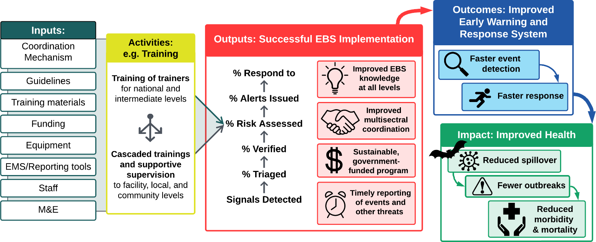
Figure 2. Event-based surveillance (EBS) Theory of Change depicting example inputs, activities, outputs, outcomes, and impacts associated with an EBS system. Source: Africa CDC EBS Framework 2023 revision
Prior evaluation results and routine monitoring reports can also inform what processes are functioning well or could use some additional support. In this regard, you may wish to include some additional analyses in your evaluation as well including a:
- Case study or focused analysis in relation to a particular outbreak/event or system attribute (e.g., simplicity, flexibility, data quality, acceptability, sensitivity, positive predictive value, representativeness, timeliness, stability, etc.)
- User experience review of EBS-related electronic tools or platforms that staff use to conduct routine work (e.g., dashboards, web and mobile-based applications, media aggregators, event management systems, etc.).
- Informatics-focused interoperability assessment between different systems used to collect, process and manage EBS surveillance data; including non-EBS data systems (e.g., IBS) that inform EWAR.

Identify collaborators: EBS program collaborators will vary country to country and can include various groups within National Public Health Institutes/Ministries of Health as well as across other government sectors who are participating in early warning surveillance and response related activities. This can also include other partner organizations supporting the implementation of EBS, such as non-governmental organizations providing facility and community health services; people who are served or affected by the program; people who plan or implement the program (e.g. past and current staff); people who might use the evaluation findings (e.g. other program designers, implementers, and evaluators); and people who are skeptical about the program (e.g. program participants, employers or associates of program participants, and developers of similar, complementary, or competing programs).³⁴
Close collaboration with these other actors within or beyond the institution where the EBS program is embedded is necessary. Activities intrinsically related to EBS program outcomes and impact are usually carried out in other units or by other institutions that might be quite “distant” from the EBS program staff in specific hierarchical structures. For example, EBS outputs like “alerts issued” might be expertly delivered by the EBS program staff to the emergency response staff (e.g. staff within the Public Health Emergency Operations Center or multi-sectoral coordination mechanism, etc.) that need to act on these alerts; however, if the communication is not timely, clear, coordinated, or actionable, these events may never receive a response or that response may be severely delayed. At the level of implementation, it will be necessary to understand these relationships and decide to what extent all relevant partners will be engaged in the evaluation process. The following questions can be used to guide which partners to include and how to engage them:
- Who is conducting the evaluation and what is their relationship with other partners?
- Who are the end users of the evaluation outcomes?
- What is the purpose of engaging with partners for the evaluation process?
- What are the power dynamics among the partners and what are their positions regarding the evaluation and efforts to strengthen or optimize the surveillance system (supportive, opposed, or neutral)?
- Who needs to be consulted/involved in implementing an EBS surveillance system evaluation and why?
- Who is being excluded and is this justified?
- What approach will you use for partner engagement?
- Who do you need to include to advocate for resources to conduct the evaluation?

There are different models of partner engagement, with empowerment being the gold standard, resources and time permitting. The approach used may also depend on the particular partner that you are working with; for example the collaboration with external partners like US CDC or World Bank for technical and financial support is likely different than one with other health sectors involved in the planning and implementation of the evaluation to ensure they are adequately represented in the process. See INSIGHT Surveillance Toolkit for more information on each of these models.
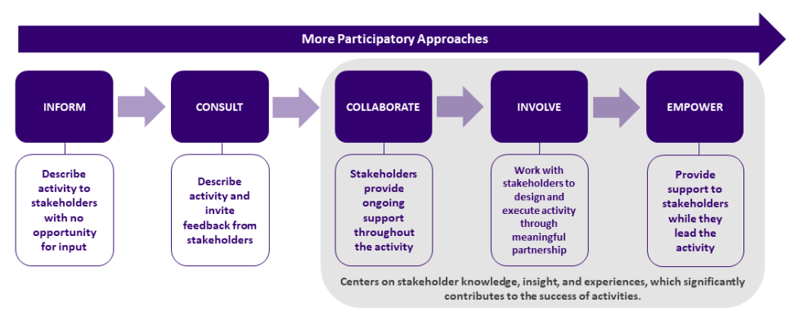
Figure 3. Participatory Approaches to Stakeholder Engagement for Assessment of Surveillance Systems. Source: INSIGHT surveillance toolkit.

Conduct literature and document review: Prior to engaging in other methods, a literature and document review of relevant EBS systems within the country/region should be conducted. This review could include surveillance reports from government bodies, published scientific reports, international assessments, EBS implementation guidelines and SOPs, and other relevant documents.

Conduct landscape analysis: An initial evaluation checklist should be filled out during the initial meetings with EBS surveillance staff and relevant partners. This checklist can help get a better idea of the general EBS systems in place and focus the objectives of the evaluation. As part of this form, or separately, it will be essential to understand where data are collected and stored and obtain an export or list of the EBS data variables collected to inform any quantitative analysis. This type of activity could also be carried out in the form of an on-site, collaborative “mapping exercise” where different people involved in the process share how they perform their function. By performing this as a group, this can identify and directly address some issues that might be prone to confusion (e.g. specific responsibilities within the institution, governance structures, ways in which information flows and different units/departments work with each other). Outcomes from an exercise like this can help develop a sense of ownership in the different people involved in the exercise and ensure the final landscape analysis is more comprehensive, reducing the risk of having a biased depiction of the landscape that could otherwise occur if only single opinions from limited institutional perspectives are used as the input. Please reference the Bottleneck-Enabler Focus Group Tool as well as the EBS Assessment Tool to inform this process.

Phase 2: Protocol and Tool Development

Evaluation Methods
Determining the methods for where, when, and how you will be conducting this evaluation is a critical component of protocol development.
Selecting study participants/population(s): This will vary depending on the evaluation objective. In general, surveillance evaluations require interfacing with officials, staff, epidemiologists, health workers, and others working in the field of public health surveillance. These could also include community members, leaders, and other end-users of EBS surveillance tools.
Site Selection, Sample Size and Population Sampling Method(s):
In most circumstances, funding and time limitations may only permit purposive sampling of a number of surveillance sites for visits and key informant interviews. Sites should be selected based on the overall goals of the evaluation, logistical practicalities, and representativeness. It is helpful to think through the two questions below to help guide the development of a sampling strategy.
- Which sites should you select?
Site selection will be directly influenced by what is currently being implemented and the goals of the evaluation. See examples of evaluation goals and site selection considerations below:
- Example Goal 1: To obtain an overall picture of how well the system is functioning.
- To understand how the EBS system functions across sites with different characteristics, careful site selection is needed to capture EBS performance in varied settings. Selection should also consider each site’s coverage size, as larger sites may represent a greater share of the data being evaluated.
- Considerations: Differences in functionality and risk profiles of sites calls for ensuring representation of different site characteristics in selection:
Site Characteristics | Reason for Consideration
Modality used | Different modalities use slightly different methods for detection and reporting (e.g. media, hotlines, facility, community); require a differing number of sites to implement; may have different timeliness and cost implications associated with implementation that could inform program planning
Rural vs urban setting | May have differing access to resources and connectivity as well as differing risk profiles especially for areas adjacent to wildlife or where land use change is occurring
Connectivity | Lack of connectivity (e.g. cell service) may impact data collection, verification, and the quality or detail of the data reported
Border regions | Are critical areas to ensure EBS capacity given the large volume of people moving
Location and Geography | Differences in geography, topography, biodiversity, history of previous outbreaks, land-use change and disturbance, etc. could all influence factors like access to resources, risk profiles regarding disease transmission and burden
Access to health facilities | This can impact timeliness of detection of facility-based EBS and the ability to respond to an event
Site density per catchment area | Number of sites per reporting catchment area (e.g. community, local, intermediate, national level) could influence detection and response rates within that catchment area
Partner presence | May impact site performance especially if some sites receive more technical or financial partner support than others
Funding levels | If specific sites are funded or resourced differently this could affect the performance of these sites
Population density | A higher population density may lead to more events. This could be seen in urban populations, but more specifically in high density camps or informal settlement communities that could be located in major cities and near borders
Areas experiencing civil unrest or conflict | These sites often have difficulty implementing surveillance due to resource constraints and access to functioning healthcare and other crucial services
Refugee hosting regions, districts, counties | These locations are often characterized by high population density and increased population risk. However, in most instances, refugee hosting communities may have better access to health facilities as compared to the host communities, which may affect performance.

- Example Goal 2: To understand the bottlenecks associated with underperforming sites and enablers associated with high-functioning sites
- This can include looking at differences amongst sites in staffing, coordination, data systems, event characteristics, patient population & community demographics, planning & procedures, policy, and resources & procurement.
- Consideration: Completing a disaggregated data review by site for completeness and accuracy could help inform which sites should be selected.
- Example Goal 3: To evaluate performance of a specific EBS modality
- This involves disaggregating the evaluation by the different modalities to understand how each modality functions within the larger system.
- Considerations: Completing a mapping exercise to understand where each modality is being implemented could be helpful in site selection. You may want to also consider some of the other site characteristics listed in example Goal 1 to reduce sample bias.

- How many sites should you sample?
It is recommended that site selection balance feasibility with representativeness. At a minimum, you should include enough sites to allow for meaningful variation across geography, EBS modality (community, facility, hotline, media), and performance levels (high- vs. low-functioning). If evaluating a national system with >20 EBS implementation sites, stratified purposive sampling should be used to select at least 20–30% of sites across:
    - Urban vs. rural settings
    - Areas with varying risk profiles (e.g., high-biodiversity zones, border regions, refugee hosting areas)
    - Modalities used (e.g., community-based vs. media scanning)
    - Implementation partners or funding mechanisms
    - Surveillance performance levels (based on previous reports or signal volume)
Data collection and analysis:
An EBS evaluation could take a purely quantitative approach by conducting, for example, a retrospective analysis of EBS data for timeliness and completeness, or a purely qualitative approach by conducting Key Informant Interviews regarding system attributes like usefulness. Time, funding, and program maturity may dictate the methods selected. However, if feasible, we recommend taking a comprehensive mixed-methods approach that combines both quantitative and qualitative methods. Taking this approach can help increase the validity of evaluation outcomes.

Here is a list of surveillance attributes³⁵ that are commonly evaluated and the recommended methods for how to evaluate them. Note that the suggested approaches for one attribute could also support the evaluation of other attributes as well – we highlighted this overlap in the EBS Question Pool.

Attribute | Assessment Approaches | Methods and Data Source
Acceptability | - Site reporting rates; partner or sector reporting rates  - Proportion of signal reports relevant to EWAR coming from the public through community or hotline EBS  - Participation rates in routine coordination meetings by partner/sector | Mixed: Interview transcripts, surveillance data, and meeting minutes/ attendance reports
Data Quality | - Proportion of events with missing or incorrect information (e.g., dates, event description, signal source, signal definition, verification source, risk assessment outcome, response actions)  - Assess the outcome of each signal detected and reported to understand the process completeness associated with routine workflow | Quantitative: Surveillance data and site level reporting logs
Flexibility | - Interviews or focus groups with surveillance staff and partners to understand system flexibility  - Interview and desk review regarding changes to the EBS system and how the system responded to the new demand | Mixed: Interview transcripts, surveillance data, annual reports, report forms
Positive predictive value | - Proportion of signals detected that result in a true event | Quantitative: Surveillance data
Representativeness | - Evaluate the catchment area of each site and the overall system  - Calculate detection efficiency | Quantitative: EBS, IBS, and Health Demographic Data; GIS data on participating sites and catchment areas
Sensitivity | - Conduct a capture-recapture analysis comparing EBS data to another surveillance system's data  - Assessment of signal definitions | Quantitative: EBS and IBS data
Simplicity | - Map workflow, partners involved, and data collection and management process (at sites and EBS hub)  - Assess interoperability between surveillance and response functions  - User experience assessment of digital platforms used to collect and manage data | Mixed: Direct observation, interview transcripts, informatics mapping, signal list, SES or other user experience (UX) data
Stability | - Assess equipment stability, accessibility and availability of data collection tools, network connectivity, etc.  - Assess staff turnover  - Assess the level of institutionalization  - Assess proportion of domestic financing and roster of official staff versus contractors or volunteers | Mixed: Interview transcripts, site visit checklist, and direct observation of data collection tool use; presences of national guidelines and SOPs; budgeted annual plan and staff rosters/ government payroll
Timeliness | - Meeting EBS and 7-1-7 timeliness targets (e.g., ≤ 7 days to detect an event) | Quantitative: Surveillance data
Usefulness | - Assessment of how EBS data are used to inform decision making (e.g. inclusion in epidemiology bulletins, dashboards, situation reports)  - Assessment of impact indicators like number of outbreaks averted, reduction in morbidity and mortality, reduced spillover of zoonotic events into human population | Mixed: EBS protocol, SOP, and surveillance strategies, interview transcripts, direct assessment of data collection tools, surveillance data

Quantitative Methods
Quantitative data can come from EBS-specific data collection tools and platforms, hotline call logs, supportive supervision checklists, training records, weekly epidemiological bulletins or situation reports, patient registers and medical records, a developed survey tool, community or facility EBS documents, or social media/media scanning records. Data analysis should occur in Excel, R or another similar statistical software package. In this section we will describe methods for measuring 1) data quality, 2) timeliness, 3) sensitivity, 4) specificity, 5) positive predictive value, and 6) representativeness. Suggested data export templates are available to inform which specific data elements should be extracted to evaluate attributes like data completeness, timeliness, and sensitivity. The EBS Questions Pool provides quantitative monitoring and evaluation indicators and suggestions on data sources that be accessed to measure these indicators.
1. Data Quality: Data quality can be assessed through two lenses: data completeness and process completeness:
- Data completeness: In the context of surveillance data, this refers to the extent to which all relevant and expected data elements (e.g., dates, location, source, description, verification status, etc.) are present and accounted for within the surveillance system. This is an important first measure to ensure that the variables in the dataset you wish to analyze are relatively accurate and complete (e.g. date and free text fields). If there is a large proportion of missing data, you may not be able to adequately estimate process completeness or any other attributes that rely on quantitative analysis. A good measure is to aim for is ≥80% data completeness^{36,37}.
- Process completeness: This is the proportion of signals or events that progress through each EBS step. This helps to better understand how data are being processed and can identify where additional analyses should take place during a site visit or focus group. If possible, breaking this analysis down by location, modality (i.e., community, facility, media, hotline), source (newspaper name, facility name), and risk level assigned can allow for a more in-depth analysis. Suggested indicators can include:
  - % of signals triaged of those detected
  - % of triaged signals verified
  - % of verified signals risk-assessed
  - % of risk-assessed events with alerts issued
  - % of alerts resulting in response

Process completeness results can trigger additional analyses that may be needed to fully understand bottlenecks and enablers of the system. Please see the table below for some examples. A more extensive list is in the Data Export Template.
Indicator | Trigger for additional analysis
% of triaged signals verified | All signals that pass triage should undergo verification. If a large proportion (e.g., >70%) of signals that pass triage were not verified as events, why? Were they discarded as not being true or was the process of verification not completed, and why? If you are unable to verify signals, you may need to identify new focal points or better understand why the existing focal points are not available to support this function.
% risk-assessed events where an alert was issued | Alerts should theoretically be issued for all events. If there are a large proportion of events where alerts are not being issued, this may require further analysis to understand why. Are these events that are primarily low risk and may not require an alert for action? Or is there a breakdown in communication between the team issuing alerts and those that respond to them?

2. Timeliness: There are several timeliness indicators that can be referenced for this analysis including those listed in the Africa CDC EBS framework^{3,13} as well as 7-1-7³⁸. We recommend including at least the following:
- Timely Detection = Detection Date – Event Start Date
- Timely Reporting = Reporting Date – Detection Date
- Timely Triage = Triage Date – Detection Date
- Timely Verification = Verification Date – Detection Date
- Timely Risk Assessment = Risk Assessment Date – Verification Date
- Timely Alert = Alert Date – Risk Assessment Date
- Timely Response = Initial Response Completion Date – Response Start Date

These timeliness indicators should be based on internal timeliness targets that are set by the country/region. If these do not exist, consider the following diagram to help inform this analysis.
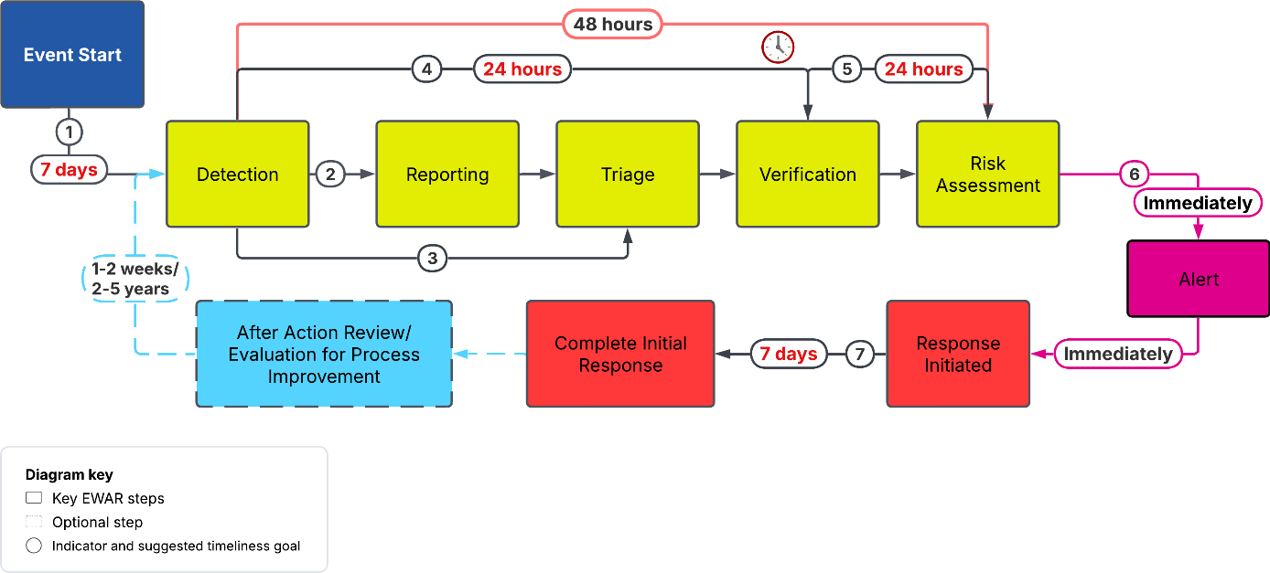
Figure 4. Suggested timeline between each EWAR step
Note there are a couple of different nuanced points about these suggested timeliness indicators that may be helpful to clarify regarding both detection and response steps:

For detection there is a difference between the
  - Time elapsed between event start and event detection by original source (for example a community informant, media outlet, person calling a hotline)
and
  - Time elapsed between event detection by original source and event detection by the EBS system (meaning time when the information enters the system through any of its input channels: community surveillance, media scanning, hotline).

This delay between event start and event detection by the EBS system does not fully depend on the system’s ability to be timely, but also on when the event is being picked up by the initial source. Not considering this could lead to biased results, or an artificial sense of underperformance by the system. For example:
- Event X starts on day 1.
- Newspapers report on Event X on day 5.
- EBS system detects Event X through media scanning on day 6.

If we only consider c and a to evaluate the system’s timeliness, we will conclude that the system has a lag of 5 days (c-a = 5), while it was actually able to detect the event within 1 day (c-b=1). This could also help determine which sources are most helpful (i.e. less delayed) in specific settings or for specific events and therefore inform decisions such as shifting from one EBS method to a different one as needed.

In regard to response timeliness indicators, while response actions are not part of EBS, it is still important to understand if and how the alerts that you are issuing are being acted upon. We included suggested response-related actions and timelines below as well as additional suggested steps that you may want to consider after an event has ended.

An additional measure of optimal timeliness could also be integrated to further understand existing capacity
- Timely Detection: Number of unique signals detected within 7 days of event start divided by total number of detected signals.
- Optimal Timely Detection Capacity: 80% or more of events detected by EBS were detected within 7 days of event start. (Africa CDC Scorecard Indicator 1.2)

3. Sensitivity: Sensitivity measures a system’s ability to detect true public health events. There are several ways of going about collecting data and calculating sensitivity – four options are briefly described below.
- Capture-recapture analysis comparing the EBS data to another surveillance system (e.g., MoH indicator-based or veterinary surveillance system) to determine the proportion of events that were captured by EBS compared to other systems and how fast the event was captured in each system. Note that because EBS systems use signal definitions that are much more sensitive and not specific to a particular disease or condition, you will need to be able to link your EBS events to a confirmed (e.g. lab, clinical) etiology to compare and match these to a case being reported in an IBS system. To simplify this analysis, you will want to pick a few different priority conditions/diseases and track the detection and reporting dates of these within each system, looking also at other key linking variables like location. In another method of capture-recapture analysis, using case-based data, you could also identify spatiotemporal clusters of conditions/diseases to define an “outbreak/event”^{39,40}. The sensitivity of EBS against the denominator of all known outbreaks/events of the selected pathogens in the evaluation area as identified in steps 2 and 3. Using capture recapture methods, estimate the “true” number of outbreak events. Using this revised denominator, re-assess EBS sensitivity.
- Retrospective review of known events in the past year to assess what proportion were detected by EBS. This could be done by comparing the EBS-detected event list to a gold standard list or lists (e.g., WHO/IHR-reported outbreaks, verified case logs, weekly epi bulletins, rapid response team documentation, after-action reports, etc.), ensuring an exhaustive accounting of all known events during the study period.
- Scenario simulations offer a prospective way to test the sensitivity of an EBS system by evaluating how well it detects the events it should detect under realistic conditions. This is done by inserting known signals or events (e.g., zoonotic outbreak, chemical spill) into the workflow and observing the system’s response. The scenarios can be mock or real-world inspired. Scenarios can be implemented in training simulations, to monitor coverage of priority conditions, staff or site performance, and evaluate when new signal definitions or modalities are introduced.

Conducting Scenario Simulations (step by step)
- Select Priority Event Scenarios
  - Choose 3–5 realistic, high-priority events the EBS system should detect (e.g., cluster of unexplained deaths, animal die-off in a border region, chemical spill)
  - Include events that vary by location, modality, and urgency.
- Determine the Simulation Modality
  - How will the scenario be introduced into the system?
    - Media scanning: Plant a mock article or blog post.
    - Hotline: Call in a scripted signal.
    - Community EBS: Have a community volunteer report a simulated event.
    - Facility: Simulate a cluster of unusual symptoms in a patient register.
- Conduct the Simulation
  - Insert each mock event through the appropriate channel(s).
  - Ensure only designated observers (not frontline staff) know the simulation is occurring if testing actual workflows.
  - Document when and how each signal was responded to and processed.
- Evaluate System Performance and Score Scenarios
  - For each scenario, assess the enablers and bottlenecks. Identify where breakdowns occurred and whether they were due to tools, processes, definitions, or staff.
Example analysis:
Scenario | Detected | Verified | Alert Issued | Response Triggered | Timeliness Met? | Notes
- Unexplained Deaths in Rural Area | ✅ | ✅ | ✅ | ✅ | ✅ | System responded appropriately
- Rumor of Chemical Spill on Facebook | ❌ | — | — | — | — | Missed due to source not routinely monitored
- Animal Die-Off Near Border | ✅ | ❌ | ❌ | ❌ | ❌ | Verification not completed; no alert issued

- Signal Definition Analysis of Sensitivity: Signal definitions are critical to the performance of EBS. A sensitivity analysis of signal definitions helps determine whether the definitions currently used are detecting the right types and numbers of events without missing critical threats. This analysis evaluates whether the definitions in use are too narrow (risking missed events) or too broad (resulting in excessive noise, overwhelming the triage process), and whether they are applied consistently across sites. Outcomes can help identify the necessary modifications to the existing signal list and improve field staff guidance and job aids to ensure consistent interpretation.

Conducting Signal Definition Sensitivity Analysis (step by step)
- Stratify Signals by Outcome by dividing signals into at least two groups:
  - True Positive Events: Signals that were triaged and verified as legitimate public health events.
  - False Positives: Signals that were discarded in the triage process because they were irrelevant to public health and EWAR (or not verified as a true event).
  - Optionally, include Missed Events identified through other sources but not detected by EBS.
- Assess Performance of Each Signal Definition by calculating the
  - True Detection Rate = # verified events detected by the definition ÷ total events of that type known to occur (from other sources or gold standard).
  - Discard Rate = # signals using this definition discarded at triage ÷ total signals using this definition.
  - Ambiguity or Overlap = # signals that match more than one definition.
- Identify Patterns
  - Are some definitions: Rarely used? Overused but rarely verified? Triggering many false positives?
  - Are field staff interpreting the definitions differently across sites or modalities?
- Supplement with Qualitative Feedback: Conduct brief interviews or focus groups with users (community workers, hotline staff, data analysts) to:
  - Understand how definitions are interpreted.
  - Identify common points of confusion or ambiguity.

Example analysis:
Signal definition | % of All Signals | % Verified as Events | % Discarded | Notes (e.g., Overlap, Confusion)
- “Sudden unexplained death” | 12% | 90% | 15% | Highly effective; used consistently
- “Social media rumor” | 25% | 30% | 65% | High false positives, needs refinement
- “Animal die-off” | 6% | 75% | 20% | Underused in non-rural areas

4. Specificity: Specificity in EBS is challenging due to the often unstructured and open nature of signal data. There are several ways of collecting data and calculating specificity including:
- Proportion of discarded signals: Measure % of signals ruled out as irrelevant or duplicates in the triage process, or not true in the verification process.
- False positive rate: Among signals verified as events, assess proportion later deemed non-public health events.
Note that high discard rates (>70%) may indicate low specificity, triggering a review of signal definitions or triage criteria.

5. Positive Predictive value (PPV): To better understand what proportion of signals reported resulted in true events, it may be helpful to calculate positive predictive value (PPV). PPV is defined as the proportion of events (i.e., verified signals) occurring within each location over the total number of signals occurring within that location.

6. Representativeness via detection efficiency (DE): This is an indicator that should be considered in countries where sub-national teams detect and report events across the whole of their country and region and not just for the location they represent. It is used to indicate how well a team is detecting signals within its own location, or in other words, the representativeness of the signals detected in its location. DE is defined as the proportion of events (i.e., verified signals) occurring within a sub-national location over the total number of signals reported by the team assigned to that sub-national location that are occurring within that location. If the DE is larger than 1, meaning more signals were detected for and occurring within a particular sub-national location than were reported by that location’s team, we interpret this as a need to improve detection capacity within that location. If the DE is less than 1, ideally this location is detecting and reporting all the events that are occurring in their location; however, a more detailed analysis to match all signals detected to events occurring in that location may be needed to fully clarify this. If the DE is less than 0.5, additional analysis should also focus on the triage and verification process. For example, consider two teams: Team A (Location A) and Team B (Location B). During a given period, Location A had 100 events and Team A reported 125 signals, while Location B had 50 events and Team B reported 40 signals. Because Location B had more events than signals reported, Team B is clearly missing signals. The detection efficiency (DE) is 100/125 = 0.80 for Team A and 50/40 = 1.25 for Team B.

Qualitative Methods
Qualitative data can come from key informant interviews with national, intermediate, community, and facility level public health practitioners and administrators, and community members and leaders (including NGOs, associations, etc.). NVIVO® or similar software can be utilized for any qualitative analysis. Qualitative data collected will be analyzed using one of two techniques, depending on program goals, funding, and analysis capacities (see below). Considerations should be made for any translation or cultural adaptation needed to ensure clear communication and accurate data capture, interpretation, and analysis. For more information on designing a qualitative research project, see this guide.

Qualitative data can be collected and analyzed using one of two techniques, depending on resources and time:
Rapid Qualitative | See here for instructions. Rapid qualitative analysis, without the need for specific software, is best suited for analyzing targeted qualitative questions within a larger mixed methods study. Such qualitative questions should be narrow in scope, or they should scaffold onto surveillance system attributes (e.g. timeliness, acceptability, etc.).
Thematic Qualitative using Excel or NViVO/other software | - Using Excel: See here for instructions. Also, see this YouTube channel for instructions in video format.  - Using NViVo® or other software: See here for instructions.

Key informant interviews/focus groups: Interview questionnaires can be developed based on input from meetings with partners, literature review, and the EBS questions database. Data collection can be paper-based or collected digitally with KoboToolbox or similar open-source software with offline use capabilities and ability to capture audio and photos. See below for some modality specific questions.
Questions for evaluating different modalities:
- Media scanning:
  - How often is media scanning done? Do you use any automation to help triage? How could the current media scanning process be improved to increase timeliness or accuracy?
  - Do you scan media in different languages? In what ways have language or cultural differences affected your ability to detect signals?
  - What sources do you scan? (internet, radio, newspaper?) How do you decide which sources or platforms are most reliable or high priority to monitor? What challenges do you face when identifying credible information from different media sources?
  - Can you describe a recent situation where media scanning helped detect an important event?
- Hotline:
  - What are the hours of operation? (24/7, other hours?)
  - Do you use any automation to help triage? What are the most common types of calls or signals you receive, and how do you handle them?
  - How is the public sensitized about the hotline? How do callers typically learn about the hotline, and what feedback have you received from the public?
  - Are operators multi-lingual?
  - What difficulties do operators experience when triaging or escalating calls?
  - Tell me about a time when the hotline played a key role in early detection or response.
  - If you could change one thing about the hotline system, what would it be and why?
- Facility-based:
  - What type of facilities are implementing?
  - Are you using facility-specific signals? What factors make it easier or harder for facility staff to recognize and report signals?
  - Describe the process a facility follows when staff suspect an unusual event. How do facility staff coordinate with local, intermediate or national teams after detecting a signal?
  - Can you share any lessons learned from past facility detections or missed events?
  - What additional support or tools would help facilities improve EBS reporting?
- Community-based:
  - Who primarily detects signals? CHWs? Anyone else (e.g., traditional healers)?
  - Are they responsible for other community level projects?
  - Are the staff volunteers or paid workers? What motivates volunteers or community health workers to participate in EBS activities?
  - Do staff have job aids to support detection?
  - Are guidelines or training sessions developed for community members? How do community members typically share information about unusual health events?
  - What barriers—such as trust, logistics, or resources—affect community reporting?
  - Can you describe an example where community detection led to a rapid response?
  - How do you think the community EBS system could be strengthened to encourage more timely or accurate reporting?

Additional Analysis
Beyond the core quantitative and qualitative evaluations, this section highlights additional analyses that can be conducted to deepen understanding of EBS system performance and impact. These optional methods—such as user-experience assessments, economic evaluations, or modeling of outbreaks averted—provide evidence that goes beyond basic indicators. Incorporating one or more of these analyses can reveal underlying drivers of performance, highlight cost–benefit relationships, and identify opportunities for innovation or system optimization. Countries can select the analyses most relevant to their objectives, resources, and data availability to strengthen both the credibility of findings and the actionability of recommendations.
Bottleneck-Enabler Focus Group/Case Study: This activity focuses on a key informant’s experiences with a specific event or disease outbreak as it relates to the EBS system. This can be used to reflect on the bottlenecks and enablers associated with a specific event detected through EBS to help identify recommended actions to improve an EBS system. This activity can be incorporated into an evaluation, held as a stand-alone activity, or integrated into part of a larger EBS training. It can take the form of several individual interviews or a focus group. See this additional resource for tips on conducting an Outbreak Case Study Focus Group.

User Experience (UX): If a mobile application, dashboard, or other EBS-related tool or platform is routinely used to conduct EBS activities, it may be of interest to evaluate the user experience associated with the use of these digital solutions for process improvement. It is recommended to include both qualitative and quantitative methods when assessing UX^{41,42}:
- Usability testing: Observe users navigating EBS dashboards or apps using a standard set of tasks. Note errors, completion times, and navigation issues.
- Surveys: Use structured Likert-scale questionnaires to assess satisfaction, perceived ease of use, usefulness, and trust in system outputs.
- Focus group discussions or in-depth interviews: Explore users’ perspectives on accessibility, barriers, and perceived value of EBS tools.
- System analytics: Analyze log data to assess usage frequency, duration, and dropout points.

Examples of several tools: System Usability Scale (SUS)^{43,44}, Single Ease Question (SEQ), NASA-TLX (Task Load Index)⁴⁵, and the Usability starter kit from Digital.gov⁴¹.

Assessing effectiveness of an intervention: You may want to assess the effectiveness of an intervention that was implemented to help improve overall EBS performance. This could include assessing an element like signal detection, process completeness, and timeliness before and after a training or introduction of a new data collection tool.

Repeat evaluations: Similar to evaluating the effects of an intervention, you may also want to see how a system is performing overall every few years (suggested that this should be done at minimum every 5 years). Including consistent indicators and methods can allow you to compare current evaluation outcomes to previous evaluation outcomes, hopefully demonstrating improved capacity, system optimization, and performance overtime.

Outbreaks averted: To estimate how many potential outbreaks were prevented or mitigated due to early detection and response through EBS, this indicator can estimate system impact on morbidity, mortality, and public health threat containment. Outbreaks averted are defined as the number of events detected early through EBS that, based on risk assessment outcomes and response timelines, likely would have escalated into larger outbreaks if not for timely intervention. This is a modeled estimate and should be interpreted in context, not as a direct count. Statistical consultation and historical data will be useful to help define P(Escalation) values by event type:

Outbreaks Averted = (P(Escalation) – P(Escalation | Timely Response)) × Verified EBS Events with Timely Response
Where:
- P(Escalation) = Estimated probability that a given event would have escalated without intervention (e.g., 0.6 for an uncontained cholera cluster).
- P(Escalation | Timely Response) = Estimated reduced probability of escalation with rapid detection + response (e.g., 0.1).
- Verified EBS Events with Timely Response = Count of events meeting timeliness thresholds (e.g., 7-1-7 or national targets).
Example: 10 cholera outbreaks caught early by EBS, each with an estimated 60% chance of escalating without response, and a 10% chance with timely intervention:
Outbreaks Averted = (0.6 – 0.1) X 10 = 5 outbreaks averted

Estimated Reduction in Morbidity and Mortality Attributable to EBS: To estimate how much illness (morbidity) and death (mortality) was prevented or reduced due to early detection and response facilitated by the EBS system. This helps demonstrate EBS’s life-saving potential and justifies investments in strengthening surveillance systems.
Note that this is a modeled or estimated indicator and not an exact measure. Thus, caution should be used when interpreting results. External factors (e.g., concurrent interventions outside of EBS) should be considered when attributing reductions solely to EBS. This should ideally be supported with additional data (i.e., qualitative interviews, response timelines, and counterfactual scenarios). You may require collaboration with a statistician to estimate expected values using outbreak modeling tools.

Reduction in Cases or Deaths (%) = [(Expected Cases or Deaths – Observed Cases or Deaths) / Expected Cases or Deaths] × 100
- Expected Cases/Deaths = Modeled number of cases or deaths that would have occurred without early detection/response, based on historical averages, outbreak modeling, or comparator regions
Consider stratifying estimates by:
- Event type (e.g., cholera, measles, anthrax)
- Location (e.g., border zone, rural areas)
- Detection modality (hotline vs. community, etc.)
- Intervention type (e.g., vaccination, case isolation, WASH)

- Observed Cases/Deaths = Actual number of cases or deaths recorded during the event or outbreak after EBS detection and intervention
- Reduction (%) = The percentage of morbidity or mortality avoided compared to the expected burden
Example: A measles cluster was detected in Region A through EBS and responded to within 3 days, with 250 cases and 3 deaths in this cluster. In a comparable past outbreak in Region B, delayed detection resulted in 500 cases and 10 deaths. Note that a higher % reduction indicates stronger system impact.
- Expected (Region B): 500 cases, 10 deaths
- Observed (Region A): 250 cases, 3 deaths
- % Reduction:
    - Morbidity Reduction = [(500 – 250) / 500] × 100 = 50%
    - Mortality Reduction = [(10 – 3) / 10] × 100 = 70%

Reduced spillover: To estimate how many potential zoonotic events (e.g., avian influenza, anthrax, rabies, brucellosis) were detected and contained in animals or the environment before crossing into human populations due to early warning provided by EBS. This indicator helps demonstrate the value of taking an all-hazards, One Health approach in EBS systems and the benefit of multisectoral collaboration. Note that an analysis like this can only be conducted where an all-hazards approach is being implemented and where similar EBS methods are being implemented across the human and animal health sectors. It may be easier to detect potential spillover events in livestock/domestic animals that for wildlife unless there is robust wildlife surveillance system in place. Also note that not all zoonoses result in morbidity/mortality in animal species (e.g. CCHF in cattle, VHF in bats). Expert input or literature should be referenced to identify zoonotic events and to define spillover risk probabilities by event/disease. Attribution should be cautious; please make sure to also consider other interventions that may be affecting event/disease(e.g., vaccination, quarantine).

Types of Measures
- Indicator Formula (Basic): Spillover Reduction (%) = [(Expected Spillover Events – Observed Spillover Events) / Expected Spillover Events] × 100
- Alternative (If Modeling Events Averted): Zoonotic Spillovers Averted = Expected Human Infections – Observed Human Infections (following detected animal events)

Definitions:
- Expected Spillover Events: Modeled number of human spillover events based on historical trends or untreated animal outbreaks
- Observed Spillover Events: Number of human cases following verified animal health events detected through EBS
- Spillover Reduction (%): Percent reduction in expected human cases attributable to early animal event detection and response

Data Required:
- Animal health signal reports
- Dates of detection, verification, risk assessment, and control measures
- Human event/case data linked temporally and geographically to the same event
- Historical data on past zoonotic outbreaks without early detection/intervention
- Assumed spillover risk per disease (from literature or expert opinion)
Conducting Reduced Spillover Analysis (step by step)
- Identify Relevant Events
  - Filter EBS-detected animal health events (e.g., mass poultry die-offs, unusual wildlife mortality).
- Trace Potential Human Impact
  - Determine whether human cases were reported following those events.
  - Use location, timing, and exposure pathway to establish linkage.
- Model Expected Spillover
  - Based on past events or published probabilities (e.g., 10% spillover risk for H5N1 outbreaks in poultry), estimate how many human cases would have occurred without early detection and control.
- Calculate Reduction or Events Averted
  - Use the basic or advanced formula above.

Example Calculation:
Animal EBS detected 5 avian influenza outbreaks.
- Expected spillover (based on past outbreaks) = 1 human case per outbreak. Therefore, 5 human cases are expected.
- Observed spillover (human cases) = 1
- Spillover Reduction = [(5 – 1) / 5] × 100 = 80%

Consider disaggregating by:
- species (e.g., livestock, wildlife, domestic animals)
- disease/pathogen (e.g., anthrax, avian influenza)
- location (e.g., cross-border, forest fragments)
- modality (community vs. media scanning)

Economic Evaluation of EBS: Evaluating the cost and cost-effectiveness of an EBS system helps decision-makers understand the value of investments and identify opportunities to improve efficiency.
This assessment can be conducted as a stand-alone activity or integrated into a broader EBS evaluation. Recommended approaches include:
- Cost-per-signal or cost-per-event detected
- Incremental cost-effectiveness ratios (ICERs) for added modalities (e.g., hotline, community)
- Time-driven activity-based costing (TDABC) to assess resource use per EBS function (e.g., triage, verification).

Guidance for Conducting an EBS Economic Evaluation
- Define the Evaluation Scope
  - Perspective: Decide whether costs will be measured from the health system perspective (direct government and partner costs) or a societal perspective (including community time, transport, etc.).
  - Time Horizon: Determine the analysis period (e.g., annual operating costs, full system lifecycle).
  - Objectives: Examples include:
    - Cost per signal detected or per event verified
    - Incremental cost of adding a new modality (e.g., hotline, media scanning)
    - Cost savings from earlier detection and response
- Describe and Capture Program Costs. Using your mapping efforts of the program (i.e. inputs, activities, outputs, and outcomes) clarify where costs occur:

Level | Examples
Inputs | Staff salaries, training, IT infrastructure, equipment, partner contributions
Activities | Signal capture, triage, verification, risk assessment, alerts, response coordination
Outputs | Number of signals processed, events verified, alerts issued
Outcomes (1-3 yrs) and Impacts (3+ yrs) | Reduced time to detection and response, outbreaks averted, morbidity/mortality reductions. Note that one may need to use a disease-specific transmission model to translate days saved into cases and deaths averted.

  - Use a costing model to estimate all resources used:
    - Financial costs: Actual expenditure (salaries, equipment, travel, communication)
    - Economic costs: Value of donated resources or staff time not directly paid by the program
    - Method options:
      - Ingredient/Activity-based costing: Identify every activity and multiply quantity × unit cost
      - Time-Driven Activity-Based Costing (TDABC): Estimate staff time per activity and apply salary rates
- Model program effects: Link cost data to key EBS outcomes such as:
  - Timeliness improvement: Estimate (or obtain from secondary sources) the reduction in days from event start to detection/response
  - Health impact: Apply standard disability weights and life tables for the diseases most affected and translate into disability-adjusted life years (DALYs)
  - Economic impact: Capture cost offsets from health system savings due to smaller outbreaks, reduced treatment and response costs.
- Analyze and Report Cost-Effectiveness
  - Common metrics include:
    - Cost per signal detected = Total annual cost ÷ Number of signals detected.
    - Cost per event verified = Total annual cost ÷ Number of verified events.
    - Incremental Cost-Effectiveness Ratio (ICER) = (Cost of EBS–Cost of comparator)÷(Outcome of EBS–Outcome of comparator)(Cost of EBS – Cost of comparator) ÷ (Outcome of EBS – Outcome of comparator)(Cost of EBS–Cost of comparator)÷(Outcome of EBS–Outcome of comparator)
  - Present results in a clear summary table, see example below:

Metric | Value | Interpretation
Total annual cost | US$ 1.2 million | Cost to operate EBS system nationally
Cost per signal detected | US$ 150 | Each signal costs ~$150 to detect
Cost per event verified | US$ 600 | Each true public health event verified costs ~$600
Cost per day of detection saved | US$ 80 | Each day of earlier detection costs ~$80

Note: Use local data wherever possible (actual budgets, staff time logs). Clearly state all assumptions (e.g., probability of outbreak escalation). Collaborate with an economist or health financing expert when modeling DALYs or outbreak scenarios.

Ethical Review and Considerations
Typically, surveillance system evaluations are not considered human subjects research but more so part of routine public health programmatic work. This is true even if interviews are conducted, provided that interviewees are only asked questions about the surveillance system itself. Often these protocols and questionnaires still need to be reviewed by an ethical review board, but are often exempted as non-research if the aim of the evaluation is not to produce generalizable knowledge, but rather to improve a specific program or system.
Despite the non-research designation, obtaining informed consent should still be considered as a best practice. Use of informed consent as part of your interview process may change the approval steps as well as the repercussions should there be a breach in confidentiality or the consent procedure. Please see the appendix for an example informed consent narrative. Please consult with your local review board for more specific recommendations.
With the collection of any personal identifiable information (PII), it is imperative that the anonymity of these individuals is maintained and their data handled appropriately. While key PII are needed for epidemiological investigations (e.g. linking cases and sources) these should not be needed in evaluations and methods can be used to de-identify data for these purposes.

Phase 3: Implementation
If you are conducting a mixed methods approach, you may want to start with your quantitative, surveillance data analysis first, to help identify where to conduct site visits. Analysis outcomes could also help refine your questionnaire if you note any process bottlenecks, data quality, reporting or timeliness concerns that you would like to further address.

Timeline (Sample Gantt Chart):
Activities | Month 1 | Month 2 | Month 3 | Month 4 | Month 5 | Month 6 | Month 7
Hold initial planning meetings
Conduct landscape assessment
Determine scope and objective of evaluation
Draft protocol and tools
Submit protocol for ethical review
Obtain and analyze documents and datasets
Conduct focus groups/ interviews
Perform site visits
Draft and finalize report and action plan
Present report and validate action plan with partners via workshop or meeting

Site Checklist
If conducting site visits, it is helpful to create a site visit checklist to ensure consistent methods are used to evaluate each site. Evaluators should assess if a site is well equipped, if EBS processes are well understood and implemented consistently and in a timely fashion. A checklist should include the following information:
- General Site Context
  - Site name, location, type (e.g., facility, call center, district health office)
  - EBS modalities implemented
  - Number of trained staff, their roles and familiarity with EBS protocols
- Inputs and Infrastructure
  - Availability and use of EBS tools, equipment, guidelines, SOPs, job aids.
  - Observe whether digital tools (e.g., dashboards, mobile apps) are in use and functioning.
  - Gather feedback on tool usability, accessibility, and language support.
  - Review site level training records.
  - Review partner involvement and funding sources that may affect operations.
- Routine Workflow
  - Track the site level data from detection to any end processing that the site performs
  - How are signals being detected, recorded and triaged?
    - Do staff understand and apply triage criteria?
    - Evaluate the proportion of signals that are discarded. Are the triage decisions justified and documented?
  - How are signals verified? Is this done in a timely manner? Bottlenecks in completion?
  - Observe staff conducting a risk assessment. Is the tool used and associated outcomes in alignment with the SOP?
  - Are alerts issued for all relevant events and communicated to appropriate authorities?
  - Determine if alerts consistently lead to response actions, and if those actions are recorded. How timely is a response initiated?
  - Document staff suggestions for improving functionality or workflow.
- Site Performance
  - Has the site missed any known events? Do they have concerns about underreporting?
  - Is performance routinely reviewed with staff? Is there a feedback mechanism or dashboard available for staff to monitor performance?
  - Are data collection forms complete and include all required fields?
  - Are data stored securely and backed up appropriately?
  - How do site-level timeliness measures compare to national benchmarks?
- Action Planning
  - Identify gaps, strengths, and opportunities for improvement based on findings.
  - Debrief staff at the end of the visit and provide any site-level recommendations for improvement

Questionnaire
Ensure you have tested your final questionnaire prior to use in the evaluation. This is especially important if you are using an electronic platform to capture survey responses that incorporate skip patterns. If using a paper-based form, ensure you have printed extra copies in case additional respondents are available to participate. If conducting a focus group or interviews, consider recording these sessions to help support note taking and development of transcripts needed to conduct your qualitative analysis.

Data Export and Site Level Abstraction Tools
- If possible, try to obtain a full export of the surveillance data needed for the timeframe of your evaluation. Ask for a data dictionary and variable list to help with your selection of the variables needed to conduct your analysis. Refer to our Data Export Template and EBS Question Pool to help determine what variables you will need.
- In addition to your site evaluation checklist, you may want to collect and analyze some site-specific data. This could be obtained from any paper surveillance, supervision, or training logs that are only housed at the site. It may be helpful to pilot the use of these forms before conducting the official site visits to determine how much time it will take to collect the data needed. Additionally, it may be helpful to bring a laptop with excel or another datasheet/database type software on it, if you need to record information not previously anticipated.

Phase 4: Outcomes and Next Steps
Report Development: A final report should be generated articulating evaluation methods , key findings, and recommendations. The following outline could be considered to draft the report.
- Executive Summary
- Background and Objectives
  - Evaluation Questions
- Methodology
  - Study Design
  - Study Population and Sites
  - Sampling Strategy
  - Data Collection and Analysis Methods
  - Ethical considerations
- Results
  - Quantitative Findings
  - Qualitative Themes
  - Other results (e.g., user experience and bottleneck analysis, key findings by attribute)
- Discussion and Conclusion
  - Strengths and Gaps
  - Recommendations and Action Plan
- Annexes (tools used, site checklists, data tables)

Data visualization examples: Including tables, graphs, and figures into a final report can help with data interpretation. Below are a few different examples of basic figures that could be included to help amplify results in your report.
- System Map – creating a data flow chart or system map should be part of your initial landscape analysis. Including a figure like this can help clarify the EBS process used at the time of your evaluation.
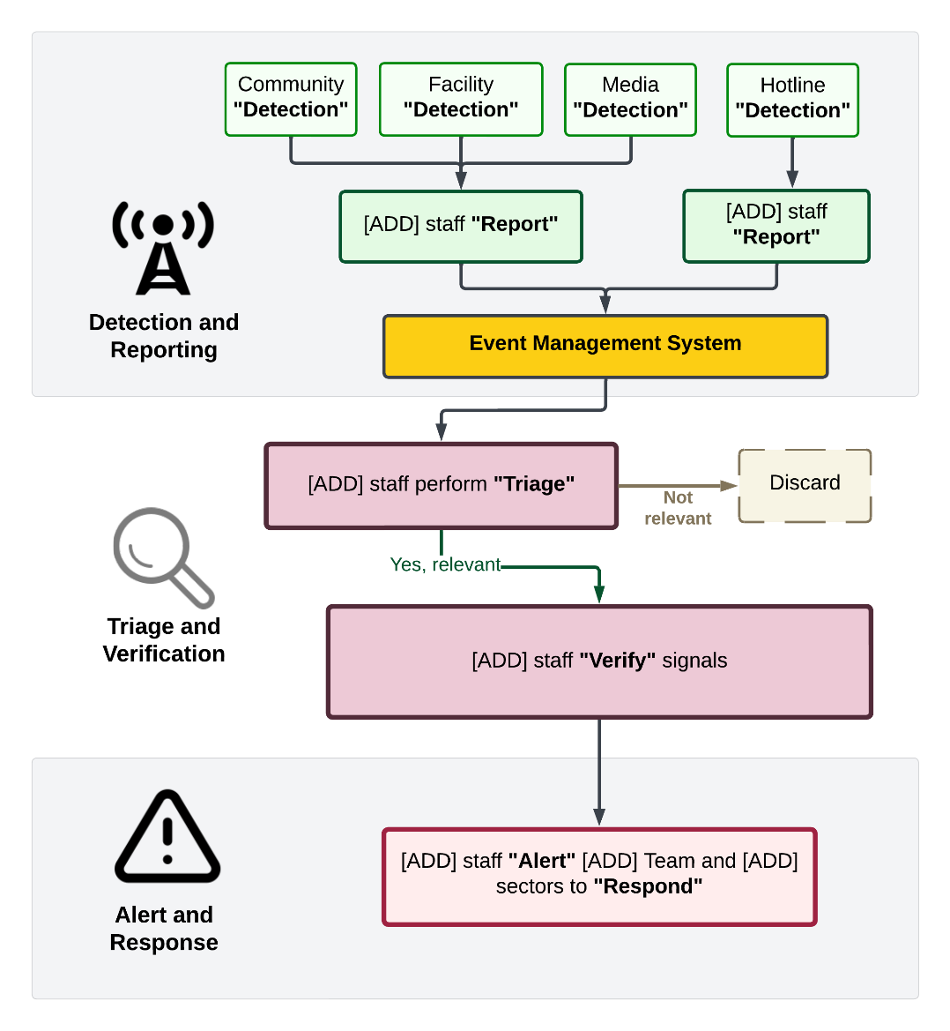

- Aggregate Process Completeness: Visualizing the number of signals detected as they pass through each step in the EBS process can help illuminate strengths and weakness in the system at a national level.
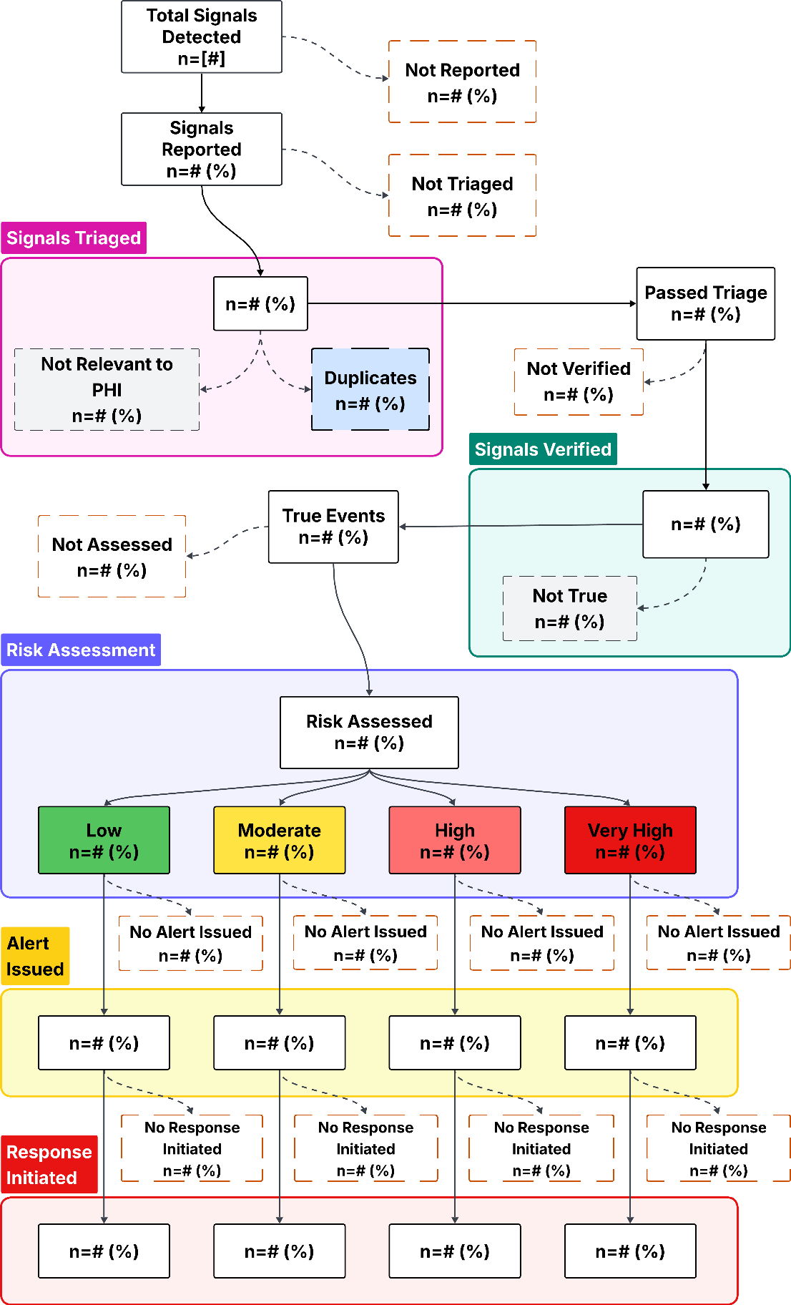

- Signal Outcomes by Sub-national Location: If a sub-national process completeness analysis is being conducted, this graphic representation could be considered to illustrate how each sub-national location is processing their EBS data.

- PPV and DE Comparisons by Subnational Location

- Map of Optimal Timeliness by Sub-national Location: If a measure like optimal timeliness is included at a sub-national level, representing this information in a map could be helpful to illustrate how each location is performing overall. This representation could be additionally compared to other measures like population density, topography, resource allocation, and areas of high tourism, biodiversity, population movement, conflict, etc.
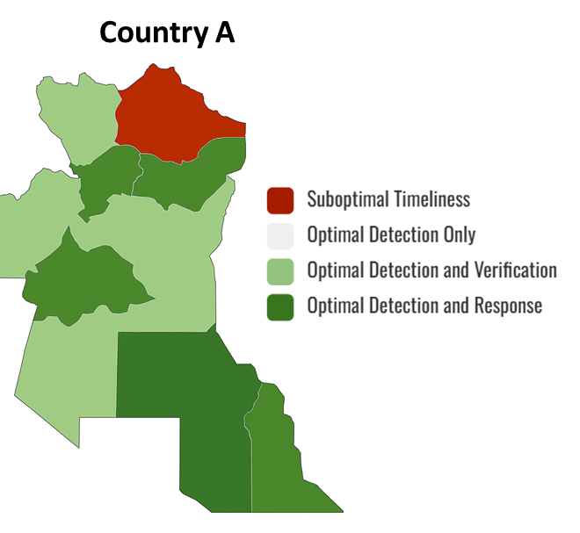

Dissemination of Results and Action Planning: After report generation, an in-country debriefing should occur with all relevant partners to share and discuss results and recommendations. This is also an opportunity to develop a suggested timeline and plan for any follow-up activities needed to improve EBS. Integrating institutional change planning, a Theory of Change framework, or a Plan-Do-Study-Act (PDSA) cycle can help guide how evaluation findings will drive system improvements.³⁴

Evaluations should end with a clear, actionable implementation plan to ensure findings lead to improvements. The plan should include:
- Prioritized recommendations with assigned responsibility (e.g., MOH, partners, facility staff).
- Timelines for action, ideally within 3, 6, and 12 months.
- Resource needs, including staff, training, infrastructure, or funding.
- Indicators to monitor progress, linked to the original evaluation framework.
- Follow-up mechanisms (e.g., quarterly review meetings, EBS M&E working group).

Example Action Plan Table
Recommendation | Responsible Entity | Timeline | Key Activities / Resources Required | Monitoring Indicator
Update hotline SOPs to clarify triage criteria | National EBS Unit | 3 months | Revise SOP; train hotline staff; distribute updated job aids; conduct community awareness campaign to improve reporting | % hotline signals that pass triage using new SOP
Strengthen cross-border signal verification | MOH + Border Health Offices | 6 months | Establish cross-border focal points; create joint verification protocol | % international and cross-border signals verified within 48 hrs
Improve community volunteer retention | Local Surveillance Office | 12 months | Provide quarterly refresher training and small incentives | Volunteer attrition rate

Acknowledgement
This guidance was drafted by the following US Centers for Disease Control and Prevention, Division of Global Health Protection Staff: Stephanie Salyer, Betsy Gunnels, Lavanya Gupta, Jonta Kamara, Jordan Baker, Emily Weston, George Odongo, Dallas Rohraff. We would like to acknowledge and thank the following partners and institutions for their review and contributions to this guidance: Africa CDC (Dativa Aliddeki), CEPI (Claire Standley), ECDC (Leonidas Alexakis, Gianfranco Spiteri, Laura Espinosa, Xanthi Andrianou), NICD (Nevashan Govender), RKI (Carlos Correa Martinez), Task Force for Global Health (Franck Amabo), Uganda Ministry of Health (Joshua Kayiwa), US CDC ORR (Anna Fisher, Tess Palmer, Alaine Knipes) and GPHEB (Lana O’Son), and WHO (Esther Hamblion and Boris Pavlin).

References
1. CDC. CDC Program Evaluation Framework Action Guide. CDC Approach to Program Evaluation. December 18, 2024. Accessed September 17, 2025. https://www.cdc.gov/evaluation/php/evaluation-framework-action-guide/index.html
2. Organization WH, UNAIDS, Surveillance UWG on GH and S. Evaluating a National Surveillance System. World Health Organization; 2013. Accessed September 17, 2025. https://iris.who.int/handle/10665/94321
3. Crawley AW, Mercy K, Shivji S, et al. An indicator framework for the monitoring and evaluation of event-based surveillance systems. Lancet Glob Health. 2024;12(4):e707-e711. doi:10.1016/S2214-109X(24)00034-2
4. Mediterranean WHORO for the E. Early Warning Alert and Response Network in Emergencies: Evaluation Protocol. World Health Organization. Regional Office for the Eastern Mediterranean; 2018. Accessed September 3, 2025. https://iris.who.int/handle/10665/327304
5. Implementation of Early Warning and Response with a Focus on Event-Based Surveillance Interim Version.; 2014. Accessed November 14, 2019. www.who.int/about/licensing/copyright_form/en/index.html
6. Kuehne A, Keating P, Polonsky J, et al. Event-based surveillance at health facility and community level in low-income and middle-income countries: a systematic review. BMJ Glob Health. 2019;4(6):e001878. doi:10.1136/bmjgh-2019-001878
7. Vigilancia basada en eventos en países de medianos y bajos ingresos: un mapa de evidencia. May 19, 2025. Accessed August 20, 2025. https://www.medwave.cl/revisiones/revisiontemas/3031.html
8. International Health Regulations (‎2005)‎: IHR monitoring and evaluation framework. Accessed November 12, 2024. https://www.who.int/publications/i/item/international-health-regulations-(-2005)-ihr-monitoring-and-evaluation-framework
9. States Parties Self-Assessment Annual Reporting. Accessed November 12, 2024. https://www.who.int/emergencies/operations/international-health-regulations-monitoring-evaluation-framework/states-parties-self-assessment-annual-reporting
10. Joint external evaluation tool: International Health Regulations (‎2005)‎ - third edition. Accessed April 7, 2023. https://www.who.int/publications-detail-redirect/9789240051980
11. WHO. After Action Review | Strategic Partnership for IHR and Health Security (SPH). Accessed November 9, 2019. https://extranet.who.int/sph/after-action-review
12. WHO. Simulation Exercise | Strategic Partnership for IHR and Health Security (SPH). Accessed November 9, 2019. https://extranet.who.int/sph/simulation-exercise
13. Africa CDC. Revised Africa CDC Event-based Surveillance Framework. Accessed April 6, 2023. https://africacdc.org/download/africa-cdc-event-based-surveillance-framework-2/
14. Tetuh KM, Salyer SJ, Aliddeki D, et al. Evaluating event-based surveillance capacity in Africa: Use of the Africa CDC scorecard, 2022–2023. Prev Med Rep. 2023;36:102398. doi:10.1016/j.pmedr.2023.102398
15. Beebeejaun K, Elston J, Oliver I, et al. Evaluation of National Event-Based Surveillance, Nigeria, 2016–2018 - Volume 27, Number 3—March 2021 - Emerging Infectious Diseases journal - CDC. doi:10.3201/eid2703.200141
16. Ndegwa L, Ngere P, Makayotto L, et al. Kenya’s experience implementing event-based surveillance during the COVID-19 pandemic. BMJ Glob Health. 2023;8(12):e013736. doi:10.1136/bmjgh-2023-013736
17. Arınık N, Van Bortel W, Boudoua B, et al. An annotated dataset for event-based surveillance of antimicrobial resistance. Data Brief. 2023;46:108870. doi:10.1016/j.dib.2022.108870
18. Stone E, Miller L, Jasperse J, et al. Community Event-Based Surveillance for Ebola Virus Disease in Sierra Leone: Implementation of a National-Level System During a Crisis. PLoS Curr. 2016;8:ecurrents.outbreaks.d119c71125b5cce312b9700d744c56d8. doi:10.1371/currents.outbreaks.d119c71125b5cce312b9700d744c56d8
19. Hoen AG, Keller M, Verma AD, Buckeridge DL, Brownstein JS. Electronic event-based surveillance for monitoring dengue, Latin America. Emerg Infect Dis. 2012;18(7):1147-1150. doi:10.3201/eid1807.120055
20. Sheel M, Collins J, Kama M, et al. Evaluation of the early warning, alert and response system after Cyclone Winston, Fiji, 2016. Bull World Health Organ. 2019;97(3):178-189C. doi:10.2471/BLT.18.211409
21. Valentin S, Mercier A, Lancelot R, Roche M, Arsevska E. Monitoring online media reports for early detection of unknown diseases: Insight from a retrospective study of COVID-19 emergence. Transbound Emerg Dis. 2021;68(3):981-986. doi:10.1111/tbed.13738
22. Mantero J, Szegedi E, Payne Hallstrom L, et al. Enhanced epidemic intelligence using a web-based screening system during the 2010 FIFA World Cup in South Africa. Euro Surveill Bull Eur Sur Mal Transm Eur Commun Dis Bull. 2014;19(18):20796. doi:10.2807/1560-7917.es2014.19.18.20796
23. Toyama Y, Ota M, Beyene BB. Event-based surveillance in north-western Ethiopia: experience and lessons learnt in the field. West Pac Surveill Response J WPSAR. 2015;6(3):22-27. doi:10.5365/WPSAR.2015.6.2.002
24. Riccardo F, Manso MD, Caporali MG, et al. Event-Based Surveillance During EXPO Milan 2015: Rationale, Tools, Procedures, and Initial Results. Health Secur. 2016;14(3):161-172. doi:10.1089/hs.2015.0075
25. Severi E, Kitching A, Crook P. Evaluation of the Health Protection Event-Based Surveillance for the London 2012 Olympic and Paralympic Games. Euro Surveill Bull Eur Sur Mal Transm Eur Commun Dis Bull. 2014;19(24):20832. doi:10.2807/1560-7917.es2014.19.24.20832
26. Espinosa L, Wijermans A, Orchard F, et al. Epitweetr: Early warning of public health threats using Twitter data. Eurosurveillance. 2022;27(39):2200177. doi:10.2807/1560-7917.ES.2022.27.39.2200177
27. Ganser I, Thiébaut R, Buckeridge DL. Global Variations in Event-Based Surveillance for Disease Outbreak Detection: Time Series Analysis. JMIR Public Health Surveill. 2022;8(10):e36211. doi:10.2196/36211
28. Kim S, Lee J, Oh J, et al. Event-based surveillance in Republic of Korea: assessment of the effectiveness of Epidemic Intelligence from Open Sources. West Pac Surveill Response J WPSAR. 2025;16(3):1-7. doi:10.5365/wpsar.2025.16.1151
29. Ratnayake R, Crowe SJ, Jasperse J, et al. Assessment of Community Event–Based Surveillance for Ebola Virus Disease, Sierra Leone, 2015 - Volume 22, Number 8—August 2016 - Emerging Infectious Diseases journal - CDC. Emerg Infect Dis. 2016;22(8):1431-1437. doi:10.3201/EID2208.160205
30. Merali S, Asiedu-Bekoe F, Clara A, et al. Community-based surveillance advances the Global Health Security Agenda in Ghana. PLOS ONE. 2020;15(8):e0237320. doi:10.1371/journal.pone.0237320
31. Clara A, Dao ATP, Do TT, et al. Factors Influencing Community Event-based Surveillance: Lessons Learned from Pilot Implementation in Vietnam. Health Secur. 2018;16(S1):S66-S75. doi:10.1089/hs.2018.0066
32. Malik EM, Abdullah AI, Mohammed SA, et al. Structure, functions, performance and gaps of event-based surveillance (EBS) in Sudan, 2021: a cross-sectional review. Glob Health. 2022;18(1):1-13. doi:10.1186/S12992-022-00886-6/TABLES/3
33. Clara A, Do TT, Dao ATP, et al. Event-Based Surveillance at Community and Healthcare Facilities, Vietnam, 2016–2017. Emerg Infect Dis. 2018;24(9):1649-1658. doi:10.3201/eid2409.171851
34. CDC. CDC Program Evaluation Framework Action Guide. CDC Approach to Program Evaluation. December 18, 2024. Accessed September 6, 2025. https://www.cdc.gov/evaluation/php/evaluation-framework-action-guide/index.html
35. Updated Guidelines for Evaluating Public Health Surveillance Systems. Accessed July 23, 2025. https://www.cdc.gov/mmwr/preview/mmwrhtml/rr5013a1.htm
36. Data quality monitoring and surveillance system evaluation - A handbook of methods and applications. September 24, 2014. Accessed September 17, 2025. https://www.ecdc.europa.eu/en/publications-data/data-quality-monitoring-and-surveillance-system-evaluation-handbook-methods-and
37. Data F under:, Quality D, Review DQ. Data Quality Review Toolkit — MEASURE Evaluation. Accessed September 17, 2025. https://www.measureevaluation.org/our-work/data-quality/data-quality-review.html
38. Frieden TR, Lee CT, Bochner AF, Buissonnière M, McClelland A. 7-1-7: an organising principle, target, and accountability metric to make the world safer from pandemics. Lancet Lond Engl. 2021;398(10300):638-640. doi:10.1016/S0140-6736(21)01250-2
39. Lan Y, Delmelle E. Space-time cluster detection techniques for infectious diseases: A systematic review. Spat Spatio-Temporal Epidemiol. 2023;44:100563. doi:10.1016/j.sste.2022.100563
40. Wang Y, Liu Y, Struthers J, Lian M. Spatiotemporal Characteristics of the COVID-19 Epidemic in the United States. Accessed September 7, 2025. https://dx.doi.org/10.1093/cid/ciaa934
41. Usability Starter Kit – Digital.gov. January 16, 2014. Accessed July 23, 2025. https://digital.gov/resources/digitalgov-user-experience-resources/digitalgov-user-experience-program-usability-starter-kit
42. Sauro J, Lewis JR. Chapter 8 - Standardized usability questionnaires. In: Sauro J, Lewis JR, eds. Quantifying the User Experience (Second Edition). Morgan Kaufmann; 2016:185-248. doi:10.1016/B978-0-12-802308-2.00008-4
43. Lewis JR. The System Usability Scale: Past, Present, and Future. Int J Human–Computer Interact. 2018;34(7):577-590. doi:10.1080/10447318.2018.1455307
44. Blattgerste J, Behrends J, Pfeiffer T. A Web-Based Analysis Toolkit for the System Usability Scale. In: Proceedings of the 15th International Conference on PErvasive Technologies Related to Assistive Environments. ACM; 2022:237-246. doi:10.1145/3529190.3529216
45. TLX @ NASA Ames - Home. Accessed July 23, 2025. https://humansystems.arc.nasa.gov/groups/TLX/index.php
46. Thirteenth General Programme of Work, 2019-2023. Accessed September 23, 2025. https://www.who.int/about/general-programme-of-work/thirteenth

Appendix

Glossary
Acceptability: Awareness and willingness of EBS staff to implement EBS; can also include participation of partners and the public in EBS
Bottleneck-Enabler Analysis: A structured process to identify barriers and facilitating factors that affect system performance
Data Quality: Completeness and validity of the data collected; inclusive or process completeness
Date of Event Detection: defined by the GPW13⁴⁶, the ideal date is the date local health authorities detect the event. Alternative dates to consider include, first confirmatory laboratory test; first sample collection date; MoH press release date; rapid diagnostic test (RDT) date; first time diagnosed as suspected case; date other external party reported to MoH; date outbreak declared; date local health authority reported to MoH; preliminary laboratory test; communication from laboratory to MoH; date first communication between third party Member States happened; and date local health authority detected signal through media.
Date of Event Response: Earliest date of any public health intervention to control the event including date field investigation started; incident management system set up; vaccination campaign started; active surveillance initiated; rapid response team deployed; active surveillance initiated; risk communication started; date quarantine started; vector control campaign launched; food/product recall started; national emergency operation centre (EOC) activated; and expert group established.
Date of Event Start (synonym: Date of Emergence): defined by the GPW13, the ideal date is the date of the index case symptom onset. Alternative measures could include symptom-onset date of first reported case (=initial case); first visit to health-care facility; suspected primary case; most likely exposure date (estimated); first exposure date (estimated); latest exposure date (estimated); outbreak start date; date of death of first reported case (=initial case); first report of the outbreak. 7-1-7 further elaborated that for endemic diseases this is the date on which a predetermined increase in case incidence over baseline rates occurred; for non-endemic diseases this is the date on which the index case or first epidemiologically linked case first experienced symptoms; and for other public health events this is the date the threat first met criteria as a reportable event based on country reporting standards
Date Initial Response Completed: according to 7-1-7³⁸, this is the date on which all applicable early response actions were completed including, initiating and investigation or deploy investigation/response team; conducting an epidemiologic analysis of burden, severity and risk factors, and performing an initial risk assessment; obtaining laboratory confirmation of the outbreak etiology; initiating appropriate case management and infection prevention and control (IPC) measures in health facilities; initiating appropriate public health countermeasures in affected communities; initiating appropriate risk communication and community engagement activities; and establishing a coordination mechanism.
Detection Efficiency (DE): proportion of events (i.e., verified signals) occurring within a sub-national location over the total number of signals reported by that sub-national location that are occurring within that location.
Evaluation: The periodic assessment of the relevance, effectiveness, and impact of activities in the light of the objectives of the surveillance and response systems.
Event: The International Health Regulations (IHR) define an event as “a manifestation of disease or an occurrence that creates a potential for disease”, which can include events that are infectious, zoonotic, chemical, radiological or nuclear in origin and transmitted by persons, vectors, animals, goods/food, or through the environment.
Event-based Surveillance (EBS): The organized collection, monitoring, assessment, and interpretation of primarily unstructured ad hoc information regarding health events or risks, which may represent an acute risk to human, animal, plant, or environment health.
Facility: Defined as a place, building or location used for a particular activity. Examples include hospitals, clinics, or healthcare facilities that engage in direct on-site patient care for humans or animals; laboratories; water treatment facilities; educational facilities; etc.
Facility event-based surveillance (FEBS): Event-based surveillance that is conducted in a facility. EBS focal points (FP) identified at these facilities support the detection and reporting of signals or events happening at these facilities that are not covered through routine indicator-based surveillance.
Flexibility: Ability of the system to adapt to changing information, needs, or operating conditions with minimal additional time, personnel, or resources
Hazard: An agent or a source that has potential to cause adverse health effects in exposed populations.
Hotline: A hotline (toll-free) is a phone line that the general public can use to contact an institution/organization about a particular health concern.
Human-animal-environment interface: A continuum of contacts and interactions among people, animals, their products, and the environment(s); in some cases, facilitating transmission of zoonotic pathogens or shared health threats.
Indicator-based surveillance (IBS): Defined by WHO as the systematic (regular) collection, monitoring, analysis, and interpretation of structured data, i.e., of indicators produced by a number of well-identified, mostly health facility-based, formal sources.
Intermediate administrative level: Intermediate administrative levels may be defined differently in different countries. For this document, the intermediate level is the health administrative level(s) below the national-level that is responsible for conducting preliminary investigations and implementing responses to reported health related events or suspected outbreaks in a given jurisdiction. The intermediate level may otherwise be referred to as districts or counties, among others. Some countries have two administrative layers (e.g., provincial and district) that make up their intermediate level.
Local administrative level: Local administrative levels may be defined differently in different countries. For this document, a local administrative level is the lowest administrative division within a country, directly above the community-level.
Media scanning (also known as “media monitoring”): The active monitoring of the content of media sources on a continuing basis to get information about specific topics.
Monitoring: Defined by WHO as the routine and continuous tracking of the implementation of planned surveillance activities (monitoring the implementation of the plan of action) and of the overall performance of surveillance and response systems.
Multisectoral: Participation of more than one sector working together with a common vision and perspective on a joint program or response to an event (e.g., a joint investigation by public health, animal health, education, and law enforcement).
Multisectoral, One Health coordination mechanism (MCM): A multisectoral, One Health coordination mechanism (MCM) refers to any formalized, standing, group that acts to strengthen or develop collaboration, communication, and coordination across the sectors responsible for addressing health concerns at the human-animal-environment interface. An MCM has routine, ongoing functions and is responsible for coordination, leadership, and governance of efforts among the relevant sectors to achieve jointly determined and agreed common goals.
One Health: One Health is an integrated, unifying approach that aims to sustainably balance and optimize the health of people, animals, and ecosystems. It recognizes the health of humans, domestic and wild animals, plants, and the wider environment (including ecosystems) are closely linked and interdependent. The approach mobilizes multiple sectors, disciplines, and communities at varying levels of society to work together to foster well-being and tackle threats to health and ecosystems, while addressing the collective need for clean water, energy and air, safe and nutritious food, taking action on climate change, and contributing to sustainable development.
Outbreak: A disease outbreak is the sudden occurrence of cases of disease in excess of what would normally be expected in a defined population, geographical area, or season. An outbreak may occur in a restricted geographical area or may extend over several countries. It may last for a few days or weeks, or for several years. A single case of a communicable disease long absent from a population, or caused by an agent (e.g., bacterium or virus) not previously recognized in that community or area, or the emergence of a previously unknown disease, may also constitute an outbreak and should be reported and investigated.
Positive predictive value: Probability that a detected signal results in a true event
Representativeness: Do the events detected represent the events occurring where EBS is implemented
Reporting: The process by which signals, or events are brought to the knowledge of the health authorities.
Reservoir: Any animal, person, plant, soil, substance - or combination of any of these - in which a zoonotic disease agent normally lives and multiplies, and for which it primarily depends on for its survival. It is from the reservoir that the infectious substance is transmitted to a human, animal, or other susceptible host.
Response: Any action triggered by the detection of a health risk (e.g., monitoring of the event, information of the public, triggering field investigation and/or implementation of any control or mitigation measures). The nature of the response will have to be adapted according to the nature of the health risk.
Risk: The likelihood of an event resulting in negative consequences for health (e.g., animal health, public health, etc.).
Risk Assessment: A systematic process for gathering, assessing, and documenting information to assign a level of risk to an event. Data collected through the risk assessment process are used to inform risk characterization and any immediate actions to be taken in response.
Risk Characterization: According to WHO, once a risk assessment team has carried out hazard, exposure, and context assessments of an event, a level of risk should be assigned. This process is called risk characterization.
Sensitivity: The ability of EBS to detect health risks. Sensitivity refers to the proportion of events that were effectively detected through EBS among all events that occurred for a given period of time.
Signal: Data and/or information considered by the Early Warning and Response system as representing potential acute health risk, such as an outbreak. Signals may consist of reports of cases or deaths (individual or aggregated), potential exposure of human beings to biological, chemical, or radiological and nuclear hazards, or occurrence of natural or man-made disasters. Signals can be detected through any potential source (health or non-health, informal or official) including the media. Raw data and information (i.e., untreated and unverified) are first detected and triaged in order to retain only the one pertinent to early detection purposes i.e., the signals. Once identified signals must be verified. When it has been verified, a signal becomes an “event”.
Simplicity: Refers to the system's structure and ease of operation, flow of data
Stability: The reliability and availability of the surveillance system
Standard Operating Procedure: a formal, written document detailing the step-by-step processes for the detection, reporting, verification, risk assessment, and response to potential public health threats. An effective EBS SOP ensures timely, consistent, and multisectoral action by providing clear guidelines and assigning specific responsibilities.
Theory of Change: A framework describing how program inputs and activities are expected to lead to outputs, outcomes, and impacts.
Timeliness: The amount of time between the EBS steps (e.g. detection, reporting, triage, verification, risk assessment, alert, and early response)
Triage: The process of screening and selecting information that is relevant for early detection purposes. The process of triaging involves two steps: 1) filtering, or screening out, irrelevant or duplicative information; and 2) selection, which is a human analyst driven process that includes selecting relevant reports based on the focus of a particular EBS unit and/or country priority. Once information is triaged, it becomes a “signal”.
Verification: Verification is the pro-active cross-checking of the validity (veracity) of the signals collected by EWAR, by contacting the original source, additional sources, or by performing a field visit to the site of occurrence. Verification requires that hoaxes, false rumors, and artefacts are eliminated from further consideration.
Usefulness: Ability for the system to meet its stated objectives (e.g. ability to detect, alert, and respond to health events in a timely fashion)
User Experience (UX) Analysis: includes investigating and assessing how users interact with the user interface (UI) of a website, web app, or landing page and using the collected data to improve the user experience. The main goal is to improve the user flow and the product’s ease of use.
Zoonotic disease or zoonoses: an infectious disease that can be shared between animals and humans; can be spread by food, water, fomites, or vectors.

List of Supplemental Evaluation Tools
- Bottleneck-Enabler Focus Group Calculations.xdsx
- Bottleneck-Enabler Focus Group.docx
- Data Export Template.xdsx
- EBS Evaluation Question Pool.xlsx
- EBS Evaluations Literature Review.xdsx
- Initial Evaluation Checklist.docx
- Suggested EBS Evaluation Tables.xlsx

Example Protocol Template
- Project Overview
  - Title of the Protocol
Example: Evaluation of the National EBS System in [Country Name], [Year]
  - Summary
List a high-level summary of the over-all activity
  - Investigator(s) and Roles:
List out names, affiliation, and role in the activity
  - Collaborators:
List any other collaborators that you will be engaging with that are not included in the activity team (e.g. investigators)
- Background and Rationale
Briefly describe EBS and its role in early warning, alert, and response (EWAR). Summarize the national EBS system structure and implementation history. Describe the importance of evaluating the system. (e.g., improving timeliness, data quality, and sensitivity). Cite relevant global technical guidelines and national health security goals.
- Objectives of the Evaluation
  - Primary Objective
Assess the effectiveness, performance, and operational quality of the national EBS system.
  - Secondary/Sub-objectives
  - Evaluate system attributes (e.g., timeliness, sensitivity, specificity, representativeness, stability). E.g. understand user experience of digital surveillance tools; assess data quality and completeness across EBS modalities; identify enablers and bottlenecks.
- Evaluation Design and Methodology
  - Evaluation Type
E.g. Mixed-methods design incorporating both qualitative and quantitative approaches.
  - Site Selection and Sampling
Describe how sites will be selected. Include number and representativeness.
  - Study Population
List key informants: national, intermediate, local EBS implementers, community members, hotline operators, users of digital tools, etc.
  - Data Sources and Collection Tools
E.g. Surveillance records, data exports, interview and focus group transcripts, monitoring reports, data collection forms, etc. List out the tools that you will be using to collect data (e.g. questionnaires, survey tools, data extraction tools, KoboToolbox or Excel/R software).
  - Evaluation Indicators and Measures
Include indicators for timeliness, sensitivity, specificity, PPV, data completeness, user satisfaction, etc.
- Data Management and Analysis Plan
  - Quantitative Analysis
Describe quantitative analysis plan (e.g., calculations for timeliness or completeness and tools).
  - Qualitative Analysis
Describe the analysis method (rapid, thematic, NVivo, etc.).
  - Data Storage
Note how and where data will be stored and for how long
- Ethical Considerations
Declare non-research programmatic evaluation. Describe consent process, data deidentification, minimal risk.
- Dissemination and Use of Results
Describe how results will be reported, shared, and used to improve the system.
- Timeline and Workplan
Attach a Gantt chart with planning, data collection, analysis, reporting, dissemination phases.
- Annexes
Include:
- Site Visit Checklist
- Interview/Focus Group Guides
- Data Export Template
- Consent Forms
- Indicator Reference Table
- Action Plan Template

Example EBS Site Evaluation Checklist
- General Information
Site name/location: _____________________________________________
Site type: □ Hotline □ Media scanning □ District Health Office □ Call Center □ Facility □ Community □ Other: _____________________
EBS modalities implemented: □ CEBS □ FEBS □ Hotline □ Media scanning □ Other: ______________
Evaluator(s): ______________________________ Date of visit: DD–MM–YYYY
Partners present/supporting: ______________________________
Funding sources:_____________________________
- Inputs & Infrastructure
Does the site have a current list of priority signals? Yes/No Comments:
Are SOPs, job aids, and risk-assessment tools available and in use? Yes/No Comments:
Are reporting/logbook tools complete and up-to-date? Yes/No Comments:
Is equipment functional (computers, phones, Wi-Fi, power)? Yes/No Comments:
Is there an updated directory of focal points and escalation contacts? Yes/No Comments:
Are digital tools (dashboards, apps, event management systems) used? Yes/No Comments:
Feedback on usability of digital tools (language, accessibility): ______________________________
Are data stored/backed up appropriately? Yes/No Comments:
- Human Resources & Training
Number of staff implementing EBS: ______
Number of staff trained in last 12 months (new vs refresher): New: ___ / Refresher: ___
Are staff familiar with signal definitions and triage criteria? Yes/No Comments:
Is there evidence of staff turnover affecting operations? Yes/No Comments:
- Routine Workflow & Process Completeness
Detection & Triage:
- How are signals detected (media, hotline, facility, community)? ____________________________
- Are triage decisions documented? ______________________________
- % of signals triaged of those detected: ______
Verification:
- Process followed and timeliness from detection → verification. ____________________________
- % of triaged signals verified: ______
Risk Assessment:
- Are risk assessments performed for all verified events? ______________________________
- Are risk levels justified and documented? ______________________________
Alerting & Response Linkage:
- Are alerts issued for all risk-assessed events? ______________________________
- Are alerts communicated to appropriate authorities? ______________________________
- Evidence that alerts triggered response actions (review logs/minutes). _______________________
- Data Quality & Timeliness Indicators
Data completeness (key variables present): ____ % (Target ≥80%)
Data accuracy (logical dates, correct classification): ____ %
Timely detection (event start → detection): ____ days
Timely reporting (detection → reporting): ____ days
Timely triage: ____ days
Timely verification: ____ hours
Timely risk assessment: ____ hours
Timely alert issuance: ____ hours
- Performance & Attributes
Acceptability (community/facility reporting rates, partner engagement): _______________________
Sensitivity (events detected vs. known events): ______________________________
Positive predictive value (verified events / signals detected): ______________________________
Representativeness (coverage of catchment area): ______________________________
Stability (staffing, financing, equipment reliability): ______________________________
Usefulness (use of EBS data in bulletins, decision making): ______________________________
Flexibility (ability to adapt to new signals/modalities): ______________________________
Simplicity (workflow clarity, data flow): ______________________________
- Stakeholder & Community Engagement
Describe coordination with district/national response units: ______________________________
Frequency of review or feedback meetings (verify minutes): ______________________________
Community awareness activities in past quarter (methods, numbers reached): __________________
Perceived barriers to community reporting (trust, logistics, language): ________________________
- Challenges & Enablers
Key bottlenecks identified by staff: ______________________________
Practices enabling timely detection or reporting: ______________________________
General recommendations for workflow/functionality improvements by site staff: _______________
- Recommendations / Action Items
Action Item | Responsible Person | Target Date

Informed Consent and Confidentiality
Sample verbal consent form:
"We are conducting a research study to evaluate the implementation of Event-Based Surveillance (EBS) using indicators aligned with the EBS Theory of Change framework, focusing on inputs, activities, outputs, outcomes, and impact. Your participation in this study involves sharing your experiences and perspectives regarding the implementation of EBS. Participation is entirely voluntary, and you have the right to refuse or withdraw at any time without any negative consequences. Your privacy will be protected, and all information shared will be kept confidential. By agreeing to participate, you consent to the use of your input for research purposes. Do you consent to participate in this study?"

Timeline will be dependent upon review board requirements and how often they meet to review and approve protocols.
The total number of staff needed will depend on the number of site visits, the evaluation design, the funds available and the amount of time dedicated to the activity. This estimate is based on a national level surveillance evaluation where data analysis is done prior to the site visits, and only 5 sites visits are made.

